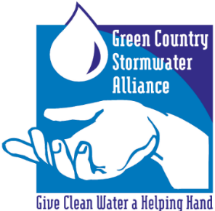
GCSA Workbook
Prepared by INCOG
January 2021, v1

GCSA EMPLOYEE TRAINING ON STORMWATER 101
Part 3: 2021 OKR04 Minimum Control Measures (MCMs)
Prepared by INCOG, January 2021
The following information contains PowerPoint slides with associated discussion of each topic. This is the 3rd of 4 Workbooks covering INCOG’s updated Stormwater 101 Education and Outreach for its GCSA Members. The material will benefit not only new staff who may be unfamiliar with stormwater permit requirements, but will also help city management and elected officials understand this complicated permit program.
This Workbook on MCMs applies to the latest draft of OKR04 which will be finalized in early 2021 and referred to in this Workbook and PowerPoint as “2021 OKR04”.
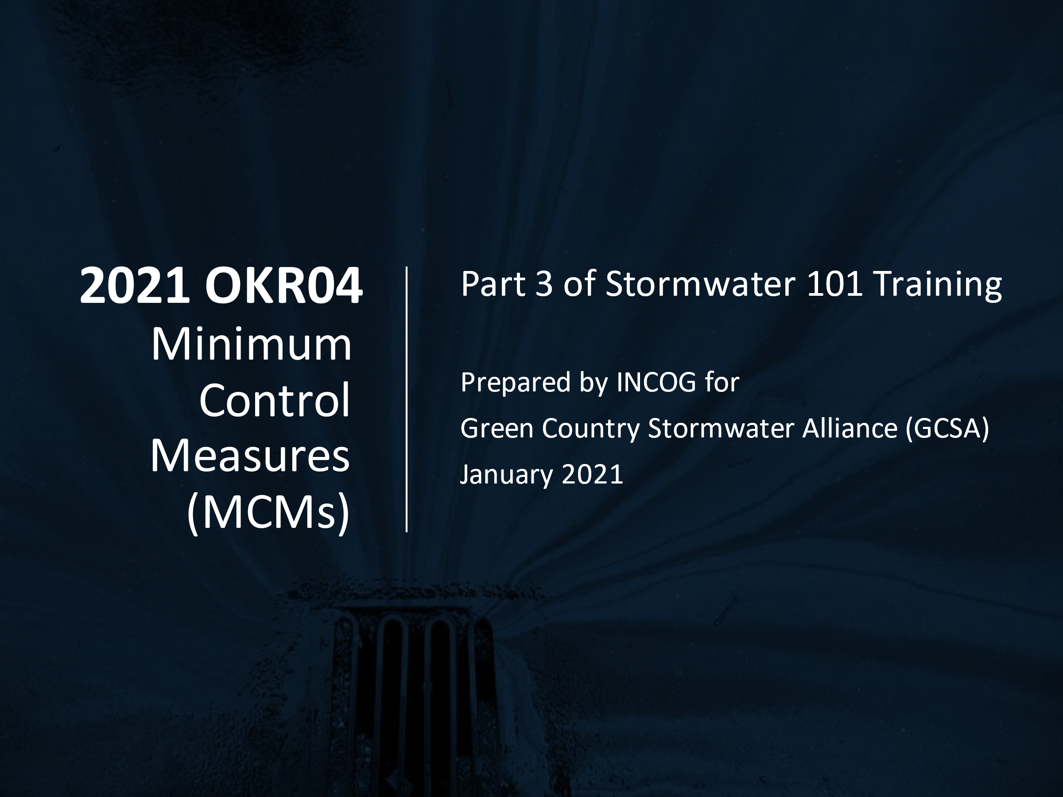
SLIDE 1: Welcome to the 3rd of 4 Workbooks addressing the basics of stormwater permitting in Oklahoma, including city and county requirements under your permit.
Part 3 will cover the six Minimum Control Measures (MCMs) in the latest draft of the OKR04 permit which will be finalized in early 2021. MCMs are categories of requirements that must be implemented by all OKR04 permittees.
OKR04 has other requirements that must also be met, but these 6 MCMs represent the fundamentals of stormwater permitting that apply to all permittees.
SLIDE 2: The 2021 OKR04 General Permit is around 50 pages in length, including title page, 8 major Sections called “Parts”, and 11 pages of 4 appendices as “Exhibits”.
Part I has become “Definitions and Acronyms” that were Part VII in the 2015 OKR04 permit.
Part II has been reorganized to consolidate basic permit eligibility and limitations on coverage. It also includes how to address endangered species.
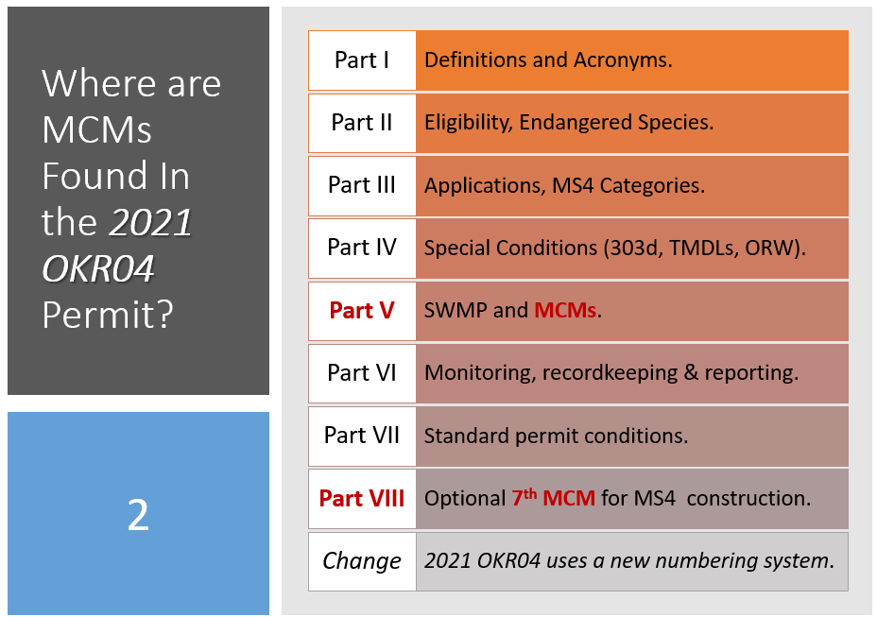
Part III describes the application process, timelines, and DEQ’s notification of coverage. It also includes the new MS4 Categories definitions.
Part IV is “Special Conditions” and compliance with Water Quality Standards. This Part covers 303(d) impaired waters, TMDLs and Outstanding Resource Waters (ORW).
Part IV is only applicable if a permittee has any of these watersheds within their MS4 area. If not, then the permittee does not have to address 303(d), TMDLs or ORW.
Part V describes requirements for preparing the Stormwater Management Program (SWMP) document, including its contents. Part V.C also includes all of the details for implementing the 6 MCMs (see Part IV.C in the 2015 OKR04 permit).
Part VI addresses requirements for monitoring, recordkeeping and reporting. It includes Quality Assurance (QA) measures that must be taken when performing sampling (“monitoring”), and for recordkeeping and reporting of data and program activities in the permittee’s Annual Report to DEQ.
Part VII covers all of the routine permit compliance conditions that are applicable to General Permits.
Part VIII describes what many call “the 7th MCM”. This is a permit option that MS4s may elect to use for local municipally owned construction activities. The 7th MCM allows the MS4 to avoid having to obtain DEQ’s OKR10 construction General Permit. The 7th MCM still requires the MS4 to prepare a Stormwater Pollution Prevention Plan (SWP3), and self-inspection and enforcement replace DEQ oversight unless warranted.
In addition to the many changes to OKR04 in the latest draft 2021 OKR04, the numbering system has also changed. For example, Part IV.C with the 6 MCMs will become Part V.C in the 2021 OKR04 permit.

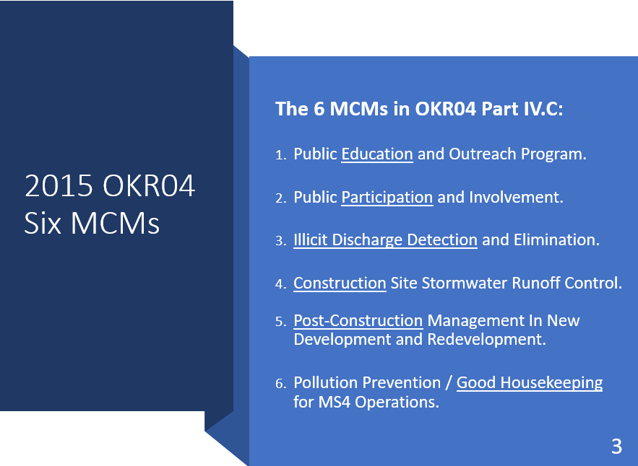
SLIDE 3: This table lists the 6 MCMs in the present (2015) OKR04 Part IV.C:
- Public Education and Outreach: The basis of this MCM is that an informed community will know what can be done to help reduce stormwater pollution, and that knowledge creates interest and motivation.
- Public Participation and Involvement: This MCM goes beyond educating the community by providing organized opportunities for citizens, schools and businesses to participate in local events that directly involve pollution reduction activities.
- Illicit Discharge Detection and Elimination (IDDE): This MCM directs the MS4 to actively search for and eliminate stormwater pollution. Each MS4 must develop a program to “detect and eliminate” Illicit Discharges.
- Construction Site Runoff Control: This MCM requires that the MS4 control the discharge of sediment and other pollutants from active construction sites that disturb 1 acre or more (≥ 1 acre) of soil, including sites with smaller disturbance if they are part of a larger “Common Plan of Development”.
- Post-Construction Management In New Development and Redevelopment: This MCM requires MS4s to implement construction and development strategies that will reduce stormwater pollution from the project once active construction has been completed, commonly by using Low Impact Development (LID).
- Pollution Prevention / Good Housekeeping For MS4 Operations: This MCM requires that the MS4 apply pollution inspection and control to its own MS4 operations, including MS4-owned facilities, staging areas, parks and the stormwater collection system itself.
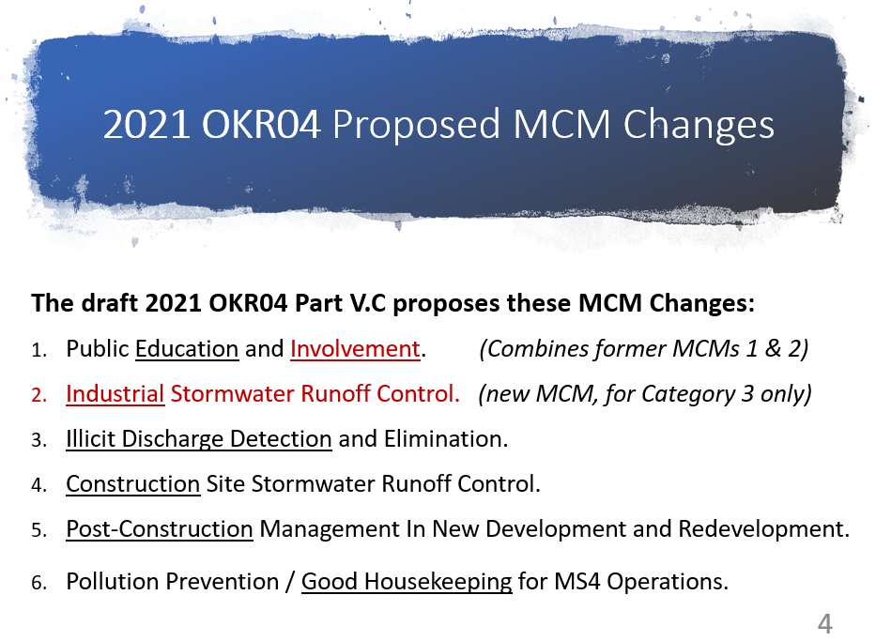
SLIDE 4: The draft 2021 OKR04 permit proposes to amend the 6 MCMs under Part IV.C (which will become Part V.C) by combining the existing Part I and II into a new Part I, and by adding a new MCM for industrial stormwater runoff control.
The other 4 MCM categories are not being rearranged.
The new MCM-1 will cover both public education and public involvement, and they are being combined because they are similar in goals and approaches.
The new MCM-2 is being proposed just for the MS4s having the largest populations (Category 3) since they are most likely to have significant industrial pollution sources. If a MS4 is not Category 3, then MCM-2 will not apply to them.
NOTE: The remainder of this Workbook will cover each MCM in greater detail. The 2021 OKR04 permit divides activities (BMPs) into “Permit Requirements” (must-do activities) and “Permit Recommendations” (should consider doing). The MCM activities presented below focus mostly on Requirements. However, over the years MS4s have implemented a combination of required and recommended BMPs.
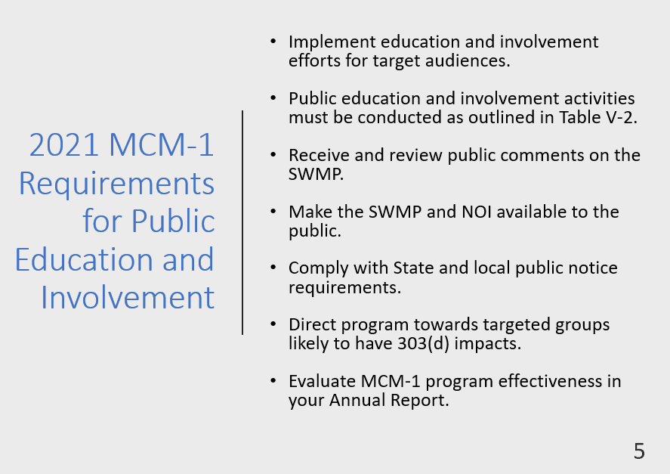
SLIDE 5 (MCM-1): The OKR04 permit includes a new Table V-1 listing specific types of education and involvement activities (BMPs) that permittees may consider implementing.
Permittees may consider using the BMPs and activities in Table V-1, or they may implement different BMPs of their own.

NOTE: The bullet items in Slide 5 are abbreviated summaries of the 2021 OKR04 MCM-1 Permit Requirements text. MS4s should consult the OKR04 permit document for a complete description of all permit requirements under MCM-1.
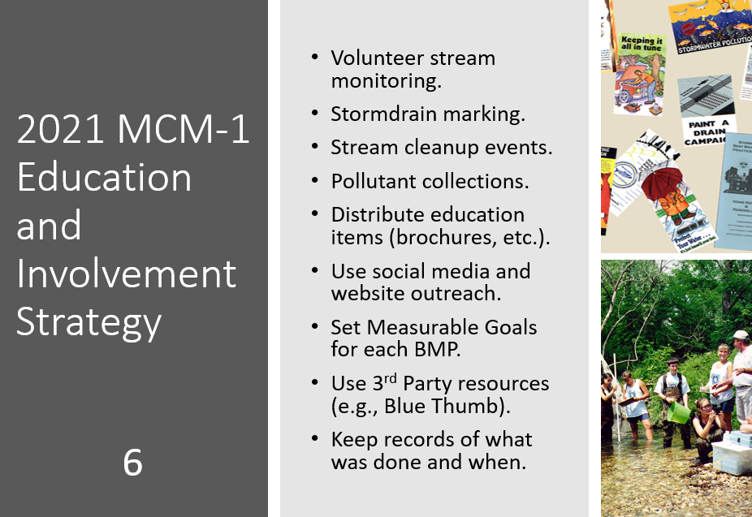
SLIDE 6 (MCM-1): OKR04 requires MS4s to identify “target audiences” which are segments within the MS4’s community that are considered potentially significant sources of pollution so that the education outreach efforts will have the greatest chance of controlling storm water pollution.
Table V-1 lists specific types of education methods that should be considered, with each being a BMP. There are hundreds of different kinds of outreach materials and activities that an MS4 may choose to implement (e.g., brochures, social media, websites, city hall display boards, etc.).
The items in Slide 6 are some of the more common ones used by GCSA members. Slide 6 also includes a reminder that records must be kept of everything that was done for each BMP so that it can be reported to DEQ in the MS4’s Annual Report.
Each outreach BMP should be scheduled and assigned a Measurable Goal (MG). The MG is a quantified target of accomplishment, such as distributing 50 Pet Waste brochures to homeowners each year.
The SWMP document must list each BMP, its deployment schedule and its MG. The MS4’s Annual Report to DEQ must assess whether or not each BMP’s schedule and MG were met. Careful records must be kept on all BMP activities during the year.
Many MS4s take advantage of 3rd party resources for a variety of public education materials and activities. INCOG has prepared a number of GCSA brochures on many of OKR04’s required outreach topics; these are refreshed periodically.
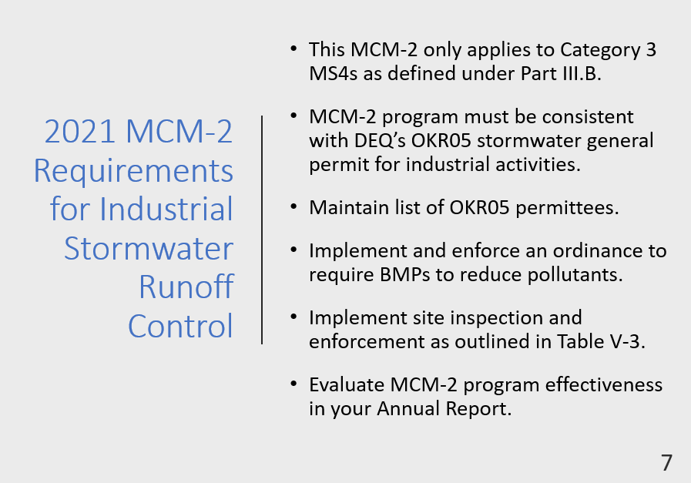
SLIDE 7 (MCM-2): This MCM covered Public Participation in the 2015 OKR04 permit. Public Participation has now been combined with Public Education under MCM-1 in the 2021 OKR04 permit.
The new MCM-2 under 2021 OKR04 is a new type of Control Measure: addressing stormwater runoff from industrial sites. Only the six Category 3 MS4s listed in 2021 OKR04 Part III.B are required to comply with the new MCM-2; all other MS4s in Oklahoma do not have any permit obligations under the new MCM-2.
All Category 3 MS4s must implement MCM-2 in a manner consistent with DEQ’s OKR05 industrial stormwater permit. Since OKR05 will likely be updated in 2022, any new OKR05 requirements affecting OKR04 Category 3 strategies must be updated within 2 years following the new OKR05 effective date.
MCM-2 requires Category 3 MS4s to implement and enforce an ordinance or other regulatory mechanism to control stormwater pollution from OKR05 industrial sites.
MCM-2 also requires Category 3 MS4s to “implement and enforce procedures for site inspection and enforcement of control measures…” The frequency of these inspections is specified in OKR04 Table V-3.
One of the MCM-2 recommendations is to expand site inspections and enforcement to industrial sites not subject to OKR05.
DEQ is preparing lists and GIS data of all OKR05 permittees in Oklahoma for MS4s.
SLIDE 8 (MCM-2): Category 3 MS4s will have to keep close scrutiny of the OKR05 industrial stormwater permit’s requirements.
MS4s will have to ensure that all of their MCM-2 requirements in their SWMP and other local procedures conform to the requirements in OKR05.
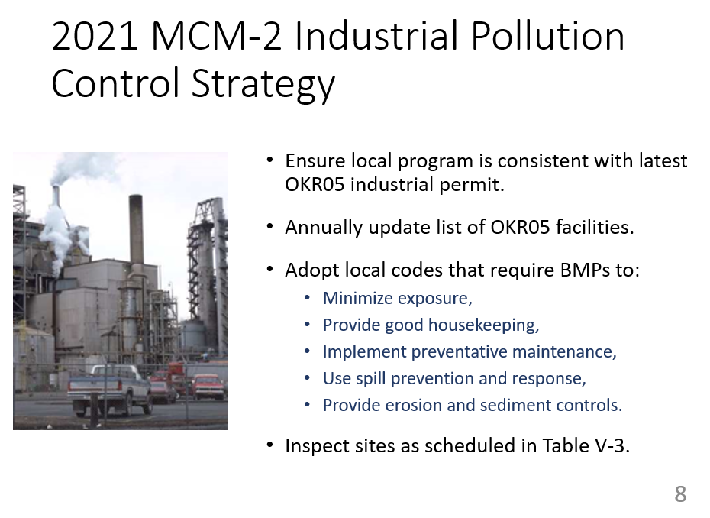
The 2021 OKR04 permit requires Category 3 MS4s to “implement and enforce an ordinance or other regulatory mechanism… to require BMPs…, provide good housekeeping, preventative maintenance, spill prevention and response, and erosion and sediment controls, as well as sanctions to ensure compliance.”.
Site inspection procedures must be consistent with OKR05 and be conducted at the frequency specified in the 2021 OKR04 Table V-3.
Category 3 MS4s must maintain and annually update a list of all OKR05 permitted industrial facilities within their MS4.
Measurable Goals and schedules for each MCM-2 BMP and activity must be established, records kept of all activities, and an assessment of each BMP included in the MS4’s Annual Report to DEQ.
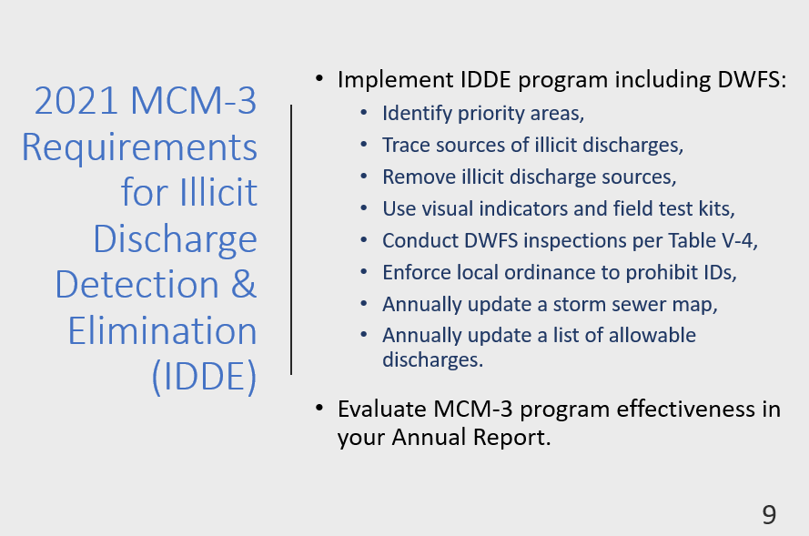
SLIDE 9 (MCM-3): The “IDDE” MCM-3 is a critical part of the stormwater pollution control program. It requires each MS4 to look for pollution and sources, and if found, to take action under local codes to eliminate the sources.
An important requirement is to ensure that MS4 employees have adequate training.
Formal procedures must be developed to detect pollution sources, trace the illicit discharge to its source, and remove the source.
A local ordinance “or other regulatory mechanism” must be adopted to “effectively prohibit … non-stormwater discharges into…” the MS4.
MCM-3 was rewritten and reorganized for clarity in the 2021 OKR04 permit.
Dry Weather Field Screening (DWFS) requirements are more clearly stated, and the new Table V-4 specifies the frequency of DWFS inspections overall and for high priority areas.
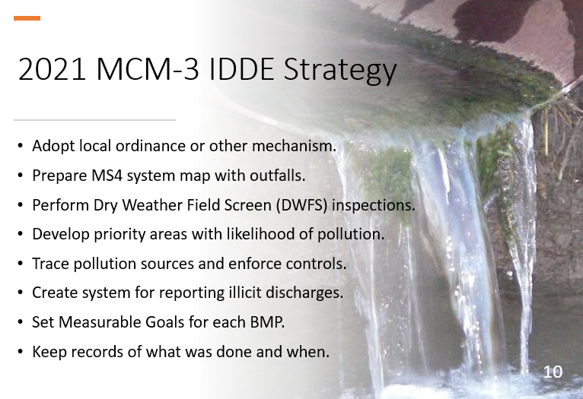
SLIDE 10 (MCM-3): The local ordinance must effectively prohibit illicit discharges. There is no need to list types of pollutants or specify minimum quantities of discharges. Any pollutant in any quantity is prohibited under the EPA and DEQ stormwater permit rules.
MS4s must develop an MS4 system map showing all “outfalls” and receiving streams. This requirement can be met in a variety of ways, from paper maps to GIS.
Each MS4 has been allowed by DEQ to define “outfall” locally. Outfalls are used in inspections of illicit discharges and for assessing water quality within the MS4. Future GCSA Training will address “outfalls” along with other Quality Assurance (QA) topics.
The new OKR04 permit clarifies how to define and use priority areas for DWFS. It also clarifies that DWFS is a first phase of the IDDE program in which potential illicit discharges are discovered. DWFS leads to more intensive source-tracking inspections which must commence within 72 hours of detection by or being reported to the MS4.
MS4s must also “maintain and annually update a list of occasional incidental non-stormwater discharges or flows as allowed in OKR04 Part II.B.2”.
MS4s must keep good records of all MCM-3 “detection and elimination” activities, including details of inspections and enforcement actions.
Measurable Goals and schedules for each BMP must be set, records kept of all activities, and an assessment of each BMP included in the MS4’s Annual Report to DEQ.
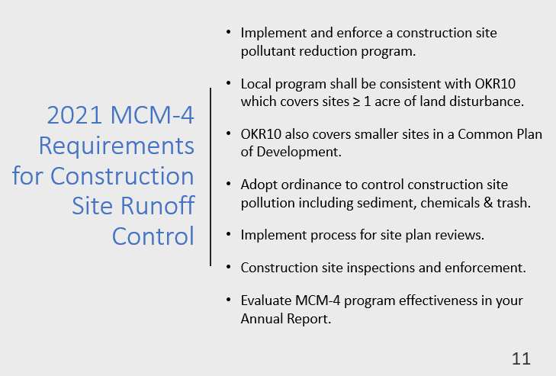
SLIDE 11 (MCM-4): This MCM has its origins in EPA’s 1990 Phase I stormwater rules. Construction is listed as one of the 11 “Industrial Activities” in the 1990 rules.
It was considered such an important pollution category that it was given its own Phase I permit program which is now covered by DEQ’s OKR10 construction general permit.
However, there are also construction stormwater control requirements under the OKR04 municipal permit which requires MS4s to control construction pollution locally.
The 2021 OKR04 permit clarifies that its MCM-4 construction requirements must be consistent with OKR10. In doing this, DEQ has deleted around 40 pages of OKR10 passages from the 2021 OKR04 permit, particularly regarding SWP3s and buffer guidance, because the same requirements are already spelled out in OKR10.
MCM-4 requires the MS4 to implement a program “to reduce pollutants in any stormwater runoff to your MS4 from construction activities”. OKR10 sets a site disturbance size of ≥ 1 acre or for smaller disturbances that are part of a larger Common Plan of Development.
The MS4 must adopt a local ordinance or other regulatory mechanism “to require erosion and sediment controls as well as sanctions to ensure compliance” where feasible. OKR10, and thus OKR04 as well, requires implementation of a Stormwater Pollution Prevention Plan (SWP3) that covers all construction site pollution.
OKR04 requires MS4s to “implement and enforcement procedures for site plan review which incorporate consideration of potential water quality impacts…”.
MCM-4 also requires MS4s to inspect and enforce the effective use of on-site control measures, including use of escalating penalties for repeat offenders.
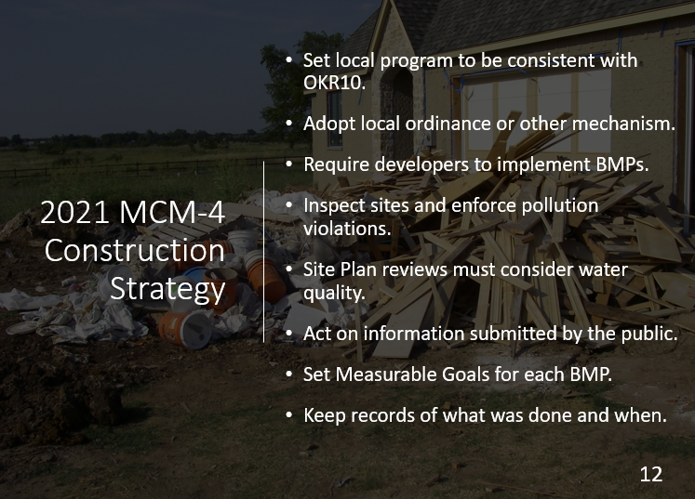
SLIDE 12 (MCM-4): OKR04 requires that the MCM-4 program be consistent with the OKR10 permit.
Since OKR10 will likely be updated in 2022, any new OKR10 requirements affecting the OKR04 MCM-4 local program must be updated within 2 years.
MS4s must adopt local codes “or other regulatory mechanisms” that provide effective pollution prohibitions and have escalating enforcement provisions.
MS4s must require developers to implement on-site BMPs to “require erosion and sediment controls” including BMPs to control all other construction site pollution.
Table V-5 in the 2021 OKR04 permit requires construction site inspection frequencies for 5 different conditions based upon MS4 Category.
MCM-4 requires the MS4 to “implement and enforce procedures for site plan review which incorporate consideration of potential water quality impacts”. This requirement will affect Public Works and Engineering departments involved in site plan reviews.
MCM-2 requires the MS4 to develop procedures for receiving reports of pollution from the public, including from construction sites. MCM-3 requires MS4 response to reports.
MS4s must keep good records of all MCM-4 construction BMPs, including details of inspections and enforcement actions.
Measurable Goals and schedules for each MCM-4 BMP must be set, records kept of all activities, and an assessment of each BMP included in the MS4’s Annual Report to DEQ.
SLIDE 13 (MCM-5): MCM-5 addresses pollution from the project itself, not its construction. MCM-5 applies throughout the life of the completed project, referred to as “post-construction”. LID is the basis for on-site post-construction pollution control.
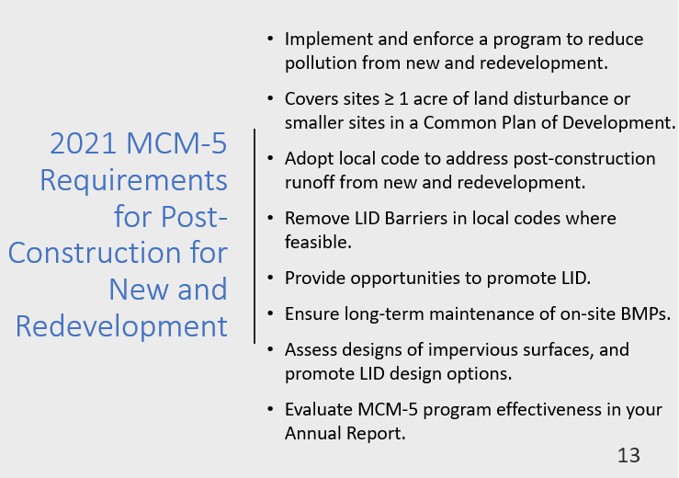
Over the years, the Post-Construction MCM-5 has been difficult to address nationwide. When EPA’s Phase II rules were finalized in 1999, LID and Green Infrastructure were not well known. Most developers refused to adopt LID fearing it would raise project costs too much, and others could not find reliable LID resources.
Now 20 years later, LID methods are in much wider use, LID education and awareness has matured, and developers are finding LID interest from their clients.
MCM-5 requires the MS4 to implement a program “to address stormwater runoff from new development and redevelopment projects that disturb greater than or equal to one acre” or for smaller projects that are part of a larger Common Plan of Development.
MS4s must adopt local codes that encourage or require post-construction pollution control and identify and remove, where feasible, barriers to LID in local codes. MS4s must also identify “opportunities to promote LID” through local strategies and codes.
MS4s must also implement plans to ensure long-term maintenance of on-site BMPs and educate developers and the public about the benefits of LID.
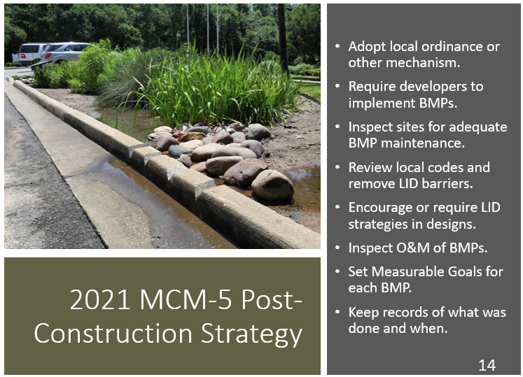
SLIDE 14 (MCM-5): MS4s must adopt local codes “or other regulatory mechanisms” that “address post-construction runoff”.
MCM-5 requires that the MS4 program “must maintain pre-development runoff conditions and ensure that controls are in place that would prevent or minimize water quality impacts.”
MS4s must review their local codes and remove LID barriers where feasible. Such code barriers might include mandatory sidewalks (which increase impervious cover), or mandatory detention basins in new subdivisions without allowing LID alternatives.
MCM-5 also requires the MS4 to identify “opportunities to promote LID” and remove any opportunity barriers. DEQ considers this to mainly apply to promotion in local codes.
Barriers to LID opportunities or in local codes can be kept, but the MS4 must “provide a justification” as to why the barrier was not removed.
MCM-5 will affect a city’s public works, engineering and planning departments by requiring considerations for LID within their community.
The MCM-5 requirement to implement procedures “to ensure adequate long-term operation and maintenance of BMPs” must include inspections performed by the MS4.
MS4s must keep good records of all of their MCM-5 activities, including details of BMP inspections performed.
Measurable Goals and schedules for each MCM-5 BMP must be set, records kept of all activities, and an assessment of each BMP included in the MS4’s Annual Report to DEQ.
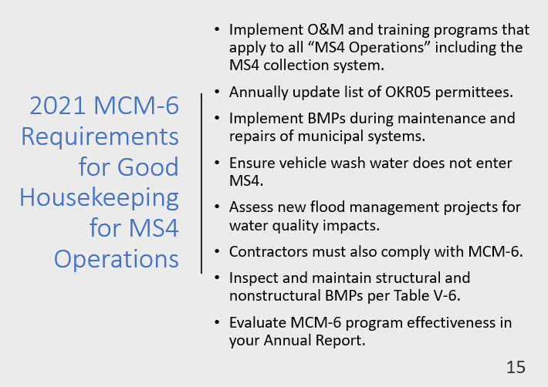
SLIDE 15 (MCM-6): This “Good Housekeeping” MCM-6 requires that every OKR04 permittee apply stormwater pollution controls to all of their municipally-owned facilities and their MS4 stormwater collection system.
In the early years of the program, most efforts focused on municipal maintenance and storage areas for vehicles, heavy equipment and materials.
The 2021 OKR04 permit clarifies that pollution prevention also includes the MS4’s stormwater collection system (its “MS4 Operations”). This includes municipally-owned streets, drainage ditches, culverts and detention basins.
MCM-6 also requires that employees be trained on preventing stormwater pollution from municipal activities at a frequency defined in Table V-2.
MS4s must maintain a list of all industrial facilities within their MS4 that have OKR05 industrial stormwater permits.
MS4s must implement “BMPs including sediment and erosion controls during” routine maintenance, water line breaks and emergency repairs, and stabilize within 14 days.
MS4s must ensure that vehicle wash waters from MS4 facilities are not discharged into the MS4 or Waters of the State.
New flood management projects such as detention basins must be assessed for impacts on water quality. OKR04 does not specify the types of assessments to be made or what follow-up actions must be taken; these are left up to each MS4.
MS4s must implement an inspection and maintenance program of structural and non-structural BMPs to reduce floatables and other stormwater pollutants according to the inspection schedule in OKR04 Table V-6.
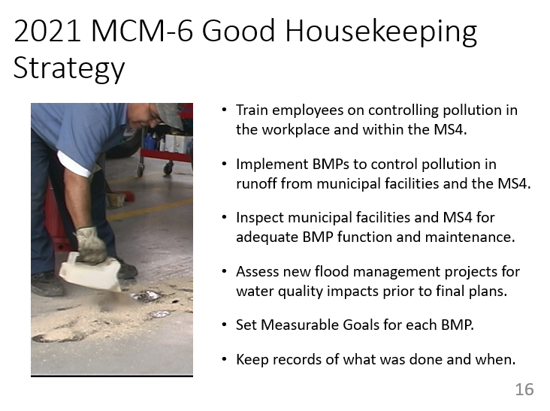
SLIDE 16 (MCM-6): The 2015 OKR04 MCM-6 required these specific employee training topics: “park and open space maintenance, fleet and building maintenance, new construction and land disturbances, and stormwater system maintenance.”
The 2021 OKR04 MCM-6 training changes this to training that “has the ultimate goal of preventing or reducing pollutant runoff from MS4 operations…”
2021 OKR04 defines MS4 operations “such as streets, roads, highways, parking lots, maintenance and storage yards, fueling areas, waste transfer stations, fleet or maintenance shops, salt/sand storage locations and snow disposal areas.”
Good Housekeeping BMPs should focus on controlling pollution from municipal operations and facilities, including maintenance of the MS4 system.
Municipal facilities and the MS4 system must be inspected to ensure adequacy of structural and nonstructural BMPs and pollution reduction effectiveness. Table V-6 in the 2021 OKR04 permit specifies inspection frequencies for OKR05 and other MS4 facilities.
Proposed new flood management projects must be assessed prior to final plans for potential impacts on water quality from stormwater pollution.
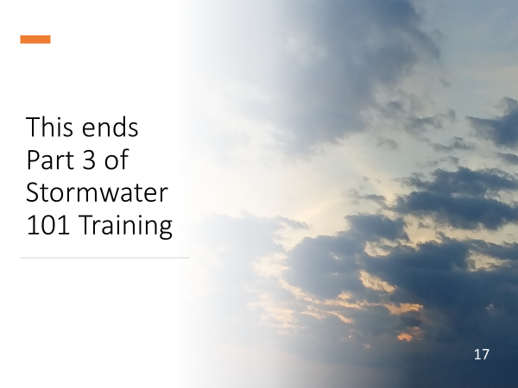
Measurable Goals and schedules for each MCM-6 BMP must be set, records kept of all activities, and an assessment of each BMP included in the MS4’s Annual Report to DEQ.
SLIDE 17: This ends Part 3 of INCOG’s Stormwater 101 Workbook series on the basics of stormwater permitting and water quality protection.
Part 4, the final in this GCSA Stormwater 101 training series, will address the four categories of special sensitive waters.
Please contact INCOG at stormwater@incog.org or (918) 579-9451 if you have any questions about GCSA or the material in this document.

INCOG DISCLAIMER: The information provided by INCOG does not necessarily reflect the views and positions of other persons or agencies. Please consult DEQ stormwater staff for information about stormwater permit requirements, implementation, assessments and enforcement. Also, contact INCOG for information about INCOG’s Green Country Stormwater Alliance (GCSA) or this document.

